

**Project Report**

**“Project Title**”

Company Marketing Report

**Submitted by:**

Malik Zohaib Zahid----Roll: 190140650-10

Shan Ali ----Roll: 190140650-17

Rizwan Anwar----Roll: 190140650-07

**Under The Guidance OF:**

**Prof**. Dr Ali Raza

Department of Marketing

**June 18th 2020**

**Project Logo and Tagline**



**Name:** Digital World Prvt ltd

**Vision:** As a top-tier employer, Digital World Limited promotes ownership, leadership, professional fulfilment, and job satisfaction. We convey productivity and business accomplishment to our worldwide customers through exact execution and specialized greatness.

**Mission:** Digital world’s limited aspires to reinforce the productivity and growth of organizations round the world with a comprehensive range of digital solutions and services.

**Swot Analysis**

**S 🡪** Strength **O 🡪** Opportunities

**W 🡪** Weaknesses **T 🡪** Threat

**Internal Strength 🡪** Revenue Generation, Intellectual Resources, Freelancing, out sourcing & insourcing, Most Products & Services

**External Strengths 🡪**  Digitalize Health Care & Education Sector’s, Bringing investment in country, Support from Government & I.T Ministries

**Internal Weaknesses 🡪** Lack of skilled persons, Lack of training

**External Weaknesses 🡪** Strict Regulations, Pakistan’s safety situation to avoid client to invests

**Opportunities 🡪** Excel and achieve global recognition, Work with best developers around the country, Enhancing skills

**Threats 🡪** Cyber Attacks, Cracking/Hacking, Viruses , Data hijacked

**Products and Services we offered**

We are providing top-notch products and reliable services within the global software marketplace. We don’t do tons of things, but whatever we do, we do it in our style and consistent with the very best standards of software engineering. With attention on specific state-of-the-art technologies, we only deliver products and services within the following market segments of the software industry:

1. Web Application Development: HTML, CSS, JavaScript, Type-Script, React, Angular 2, Node.js, MongoDB, Firebase, and Server-less Architecture.
2. Android App Development using Java
3. iPhone (iOS) App Development using Swift
4. AI, Machine Learning(ML) and Deep Learning using Python
5. Software Defined Networks (SDN) using Python
6. Fin-Tech Research and Development using Python
7. UI/UX Design

We, at Digital World, believe that software developers are the foremost valuable resources of the planet during this digital age - even more valuable than oil wells or gold mines. we expect that App creation process starts with developer’s selection and training, not once we start performing on a specific application. Given these beliefs, we've developed a singular business model that focuses on selecting top students and professionals then training them completely freed from charge to be world-class developers in selected cutting-edge technologies. As a result, we are ready to train and retain an outsized number of developers per annum within the latest state-of-the-art technologies specifically needed to deliver products and services to the above-mentioned target market segments

**What would be the pricing strategy and Why: how would you calculate the break even. Provide justification of your pricing strategy**

**Pricing Strategies for Digital Products**

* **Know the market, and cost seriously 🡪** Complete a certified assessment and assessment with the target that you know how others in the business are assessing for all intents and purposes indistinguishable moved things. By at that point, regard yours to orchestrate it against the obstruction. In the event that your thing offers disposition, reward content or a worth consolidate that contenders' things do dismiss, consider evaluating that is somewhat higher or if nothing else sway the worth joins your showing messages. On the off chance that your enemies offer equivalent things, consider how you can confine or bolster with cost without surrendering your overall gains.
* **Offer an unconditional promise 🡪** Unqualified guarantees expel the last issue with purchasing a modernized participation by emptying the risk in the trade. Customers reluctant of buying from a dark or self-governing propelled provider may be less cautious if they are certain their money isn't in harm's way. If you offer a quality thing, you should see scarcely any, benefits. Besides, if you aren't certain about the idea of your thing, return it to the arranging stage for additional changes; don't release it!
* **Let client attempt before they purchase 🡪**Almost every organization offers clients to attempt before purchase. Most organizations offer a 7-day, 21-day or 30-day free preliminary. Make certain to have an automated assistant set up that will consequently contact clients whose free preliminaries are lapsing to remind them to restore before the preliminary finishes. Consider adding an extraordinary proposal to the individuals who do reestablish before the preliminary closures to make it simple for clients to state "yes" and purchase the full membership bundle.
* **Offer a special reward 🡪** Everyone loves a free gift with a purchase. That’s why many digital products, such as e-books, add a free e-book or give an added feature in your software to your purchase. It’s an added, perceived value that can convince uncertain customers to complete the transaction. If you do offer an added bonus, be sure it adds substantial value to your core offering age
* **Test your offer and cost and be inventive 🡪** Valuing is significant, yet so too are the components around the cost on your site. The offer and innovative components work with evaluating to pull in clients to the page and convert programs into purchasers. Test diverse value focuses, new inventive strategies to grandstand highlights and advantages of your items, new invitations to take action and added worth or extra items to see which mix changes over the most prompts deals

**What would the promotional strategies**

## Promotional Strategies

## •Promotion through social media 🡪 We advance our things by online life goals, for example, Facebook, Youtube and Google+ offers an approach to manage advance things and associations in a ceaselessly loose up condition. Due to web based life advancing we are not restricted to only a solitary country. An immense number of customers can see our thing and attract with us..

## •By promoting Branded Gifts 🡪 Giving unendingly utilitarian checked favors can be a more remarkable restricted time move than giving out clear business cards. Putting business card on a magnet, ink pen or key chain. These are gifts we give our customers that they may use, which keeps our business in plain view instead of in the refuse or in a bureau with various business cards the customer may not look at.

## •By Giving away samples and products🡪 Product giveaways and allowing potential customers to test a thing are methodologies used much of the time by associations to introduce new food and family things. Countless these associations support in-store progressions, leaving behind thing tests to charm the buying open into endeavoring new things.

## •Foundations and Assistance🡪 Promoting your things while supporting an explanation can be a practical restricted time approach. Giving customers a sentiment of being a bit of something greater just by using things they may use regardless makes a triumph/win situation. You get the customers and the socially perceptive picture; customers get a thing they can use and the sentiment of helping an explanation. One way to deal with do this is to give a degree of thing advantage to the explanation your association has concentrated on having any kind of effect.

## •Mail Order Marketing🡪 Customers who come into your business are not to be overlooked as they have recently decided to purchase your thing. What can be valuable is getting singular information from these customers. Offer a free thing or organization as an end-result of the information. These are customers who are starting at now familiar with your association and address the expected intrigue bunch you have to publicize your new things to.

**What would be the distribution, how it would reach to its consumers**

**Distribution of our product🡪** There is a completely different scenario of our product distribution because in our case our product is totally digital. There is only a gap of one click between us and our customer. There is completely digital distribution of our product to our customer. The scenario is totally same even if a customer is thousand miles away from us or he is located in the next street we distribute our product digitally. We build our product digitally and we deliver our product digitally. Our customer receives their product on a text message. He doesn’t wait for hours or days or even months to get their product. He receives his product in any condition for example if he is in business meeting or any other circumstances.

**Our interactivity with client 🡪** Our client has to go our website then he choose the product and select the packages we offer like if our client is interested in developing their E-commerse website then get into web-application development section after placing their order we receive a message through e-mail and our developers start making that website and their message displays on the website that your website complete in 4 days and also our management staff were in contacting with the client during those days and once clients website is ready we send all important information to client through e-mail and client just need to put that information on the specific server and that’s it

**Discuss what strategy you will adopt to enhance the product life cycle of your product or service**

Our software products were developed under highly skilled software developers and engineers. These softwares are developed in SDLC environment means **(SOFTWARE DEVELOPMENT LIFE CYCLE)**. It consists of seven steps as you see below towards diagram:

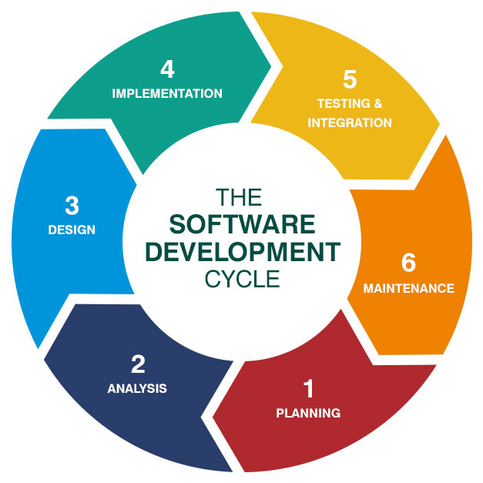

Whenever a software is cleared from these 6 steps then we start working on their development. After completing it’s development then our Quality Assurance Engineer ensures its quality and then we delivered our product to our client.

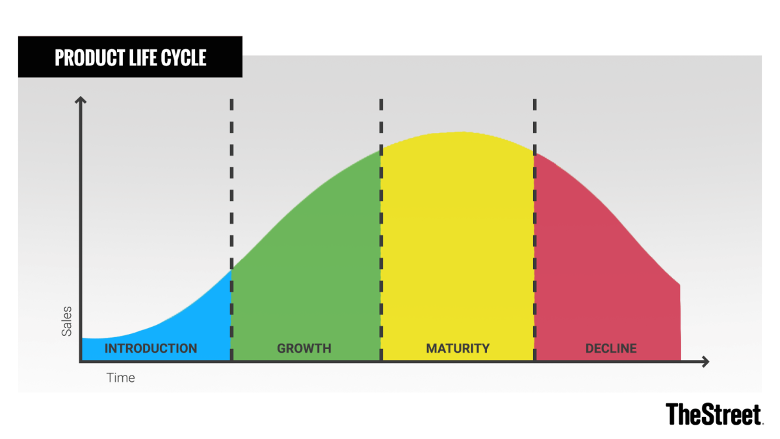

Normally Product life cycle is divided into these four stages:

1. Introduction
2. Growth
3. Maturity
4. Decline

This concept is used by management and by marketing professionals as a factor in deciding when it is appropriate to increase advertising, reduce prices, expand to new markets, or redesign packaging.

**Maintenance Phase🡪** But As you know it’s a digital product and these products were lasted for years and life time. But when our client feels that there product is now became old and he feels glitches and bugs and their performance were not that good and it does not support new features which were in in market then our maintenance engineers were start working on that software at the backend and they send new updates in which they fix their bugs, glitches and improve their performance and add extra features in that update and that the same old, buggy , old version software were totally transformed into a new product. In fact, the maintenance were always running at the backend of the software to make that product in a running position. Actually these digital product were never became old a single update were totally changed its interface. But one serious problem with these digital products is that the hackers were always find opportunity to attack on their database or hijack that product but we also provide security assurance to these products and that’s how our digital product were lasted life time without any hurdles. This is how we enhance product life cycle.

**Discuss its advertising budget.**

**Promoting Budget Allocation🡪** When we manufacture an advertising financial plan, We remembered not many things when wanting to spending.

**•Using internet based life stage 🡪** When it comes to computerized and even print media, we need programming to make promoting efforts, or handle day by day forms.

**•Outworkers or Freelancer🡪** in the unlikely event that we have a concise fight or we have to evaluate another advancing method, we may enroll a transient master before inviting on a full-clock.

**•Newly employed staff 🡪** At the moment that we enroll all day laborers, we set spending costs including their PC, development, benefits, and onboarding-related necessities.

**•By promoting or publicizing 🡪** How much money we spend on paid open entryways, for instance, physical notices, nearby notices, upheld substance, web crawler advancements, and web based life headways.

**•By content makers🡪** When we make substance, for instance, accounts, photos, or even blog sections, we need to put paid vitality into it. Going through how much money will go into causing this substance so you to can change as requirements be established on its appearance on adventure.

**Aligning Budget With Marketing Goals 🡪** What we spend and where we spend it will rely upon what we are attempting to achieve. Along these lines, when beginning to make our showcasing financial plan, we make sure that solitary burning through cash on the things required by our present promoting objectives — objectives set dependent on our crowd and their excursion from prospect to client. These could include:

* Display ads **to promote a new product** we were launching this year.
* Sponsored social media posts **to generate followers** on our new Facebook page.
* Paid search engine ads **to drive traffic (and purchases)** to a specific product page.
* Contract bloggers **to get more organic search traffic** to our company's website.

.**Spending Our Budget Smartly 🡪** At the point when we open up these spending formats and look at all the different costs definite in them. I'm not upholding for a "consistently spend more" way to deal with promoting.

I'm supporting for a "consistently spend shrewd" approach. The costs drilled down aren't required they're simply intended to manage thinking and to help guarantee that we haven't disregarded any shrouded costs.

**Discuss best possible way of creating value for customers and how would your company would create value for its customers**

Included an incentive in a significant strategy that can be use in brand mindfulness. We continued after strides in see for making an incentive for our clients

• **Always consider our client viewpoint 🡪** Consider what's essential to target and how our client support will profit them. By making a client personals to give knowledge about our current and future clients, what's important to them, and give a guide of the sort of substance we make and offer to give included worth.

• C**onsistently work to improve consumer loyalty** **🡪** Although the discussion about whether the client is in every case right or not proceeds. Client support is a certain method to keep individuals returning. We should utilize overview devices to gather our item criticism for the client and consistently attempt to make sense of our mix-ups we did in the past item.

• **Develop an essential involvement in client 🡪** Business with remarkable client experience are bound to profit referral, positive online surveys, and higher aim rates. Building a client experience additionally permits you to create sconnection with our client so we associate on levels that go just getting the deal